**Energy Resources**

The word ‘energy’ is derived from the Greek word *energeia* meaning ‘activity, operation’. Energy is a primary input for almost all economic activities and is therefore, vital for improvement in quality of life. Its use in sectors such as industry, commerce, transport, telecommunication, wide range of agriculture and household services has compelled us to focus our attention to ensure its continuous supply to meet our ever increasing demands.

While on one hand the demand for energy is increasing, on the other hand the energy resources are becoming scarce and costlier. Do there is need to search some alternative energy sources which are environmentally friendly and cost effective.

**GROWING ENERGY NEEDS**

Development in different sectors relies largely upon energy. Agriculture, industry, mining transportation, lightning, cooling and heating in buildings, all needs energy. With the demands of growing population the world is facing further energy deficit. The fossil fuels like coal, oil and natural gas which at present are supplying 95% of the commercial energy of the world are not going to last for many more years.

The world faces substantial increase in energy consumption, particularly in these disadvanted areas where population growth is still high but individual expectations for improvement are also understandably high. Whether we consider the denudation of forests to supply woods for the people of the developing world or the atmospheric pollution that accompanies the generation of electricity in coal burning power plants, environmental problems grow as energy requirements rise.

In India, per capital consumption of energy is one-fourth of the world average and one-twenty fifth that of USA. Traditional sources of energy like animal dung, wood and crop residue account to 30 % of the total energy consumption in our country, but these are being slowly replaced by modern sources of energy.

**TYPES OF ENERGY RESOURCES**

Energy resources can be described as renewable, non-renewable and sustainable.

1. **Renewable Resources of energy:** These resources have the capacity to reappear or replenish themselves by quick recycling, reproduction and replacement within a reasonable time. It includes solar energy, geothermal energy, biomass energy, wind energy, hydroelectric energy, hydrogen energy, tidal energy etc.

***Advantages:***

* Low running cost.
* Wide availability
* Decentralized power production
* Pollution free or very low pollution or eco-friendly
* Availability for future generation

***Disadvantage:***

* Unreliable supply
* Difficulty of storage
* Currently high per unit production cost
  1. **Non-renewable Sources of Energy:** These energy resources cannot be re-made, re-grown or regenerated within a short period of time, on a scale relative to its consumption. The substances with a very long recycling time are also regarded as non-renewable resources. The ***fossil fuels (coal, petroleum and natural gas)*** and *metals* once extracted cannot be regenerated at the place of extraction.

***Advantages:***

* Available in highly concentrated form
* Easy storage
* Reliable supply
* Low per unit cost production

***Disadvantage:***

* Available only in few places
* Highly polluting
* Limited supply hence exhaustible

**iii. Sustainable Energy:** Sustainable energy is a term sometimes applied to nuclear power. The nuclear power sources are not exactly renewable but they will last for a very long time because a great deal of electricity is produced form a small amount of radioactive material.

***Advantages:***

* Production of energy in a large amount.
* Uses small amount of raw material
* Very little CO2 emission
* Highly reliable.

***Disadvantage:***

* High capital investment and maintenance cost
* High waste disposal cost
* Risk of radioactivity

**NON-RENEWABLE SOURCES OF ENERGY OR FOSSIL FUELS**

* **Coal**

Coal is one of the major fossil fuel. It formed over millions of years ago from decomposition of plants. Coal is a complex mixture of C, H, O. Small amount of N and S also occurs in coal.

**(i) Anthracite (Hard coal):-** Contains maximum carbon percentage (above 90%)

**(ii) Bituminous (Soft coal):-** Contains 80% carbon (Bituminous ≡ Wood Coal)

**(iii) Lignite (Brown coal):-** Contains 70% carbon.

**(iv) Peat: -** Contains less than 60% carbon (Peat ≡ decomposed vegetable matter or dried turf used as fuel)(turf ≡ surface of earth with grass roots)

* **Petroleum:** Petroleum is perhaps the most widely used form of fuel for different purposes. It’s a cleaner fuel as compared to coal as it burns completely leaving no residue. It is obtained by fractional distillation, which is actually a complex mixture of hydrocarbons such as butane, propane and ethane, propane, butane etc. These gases are converted into liquid form under pressure as **Liquefied Petroleum Gas** **(LPG)**. One and most widely known use of petroleum is its use in domestic gas cylinder under the name Liquefied Petroleum Gas (LPG). However*, LPG is odourless but in our domestic gas cylinders it gives a foul smell. It is due to the presence of ethyl mercapton gas, which is added to LPG to detect the leakage of LPG from the cylinders*. Other advantage of the petroleum is that it can be transported very easily, which also adds to its increased use. The burning of petroleum releases atmospheric pollutants such as NO, SO2, CO, CO2, NO2 etc. These gases are smog precursors that pollute the air and greenhouse gases that contribute to global warming.
* **Natural Gas:** After coal and petroleum, natural gas is the third major source of fossil fuel. It is fast emerging as an alternate source as it is eco-friendly in characters. Natural gas is mainly composed of methane (95%) with small amount of propane, ethane, butane as well as small quantities of carbon dioxide, nitrogen, helium and hydrogen sulfide. Now a days natural gas is utilizing as in compressed form under the name **Compressed Natural Gas (CNG)** as an alternative fuel to petrol and diesel for the automobiles for transportation. CNG has greatly reduced vehicular pollution in the city. It is used in different ways-
* As domestic purpose
* As fuel in thermal power plants for generation of electricity
* As industrial purpose
* As industrial raw material in petrochemical industry

CNG is a better fuel than petrol and diesel because it

1. burns more efficiently and very little of its left unburned
2. It is cheaper fuel
3. It produces very little pollution i.e. eco-friendly in nature.
4. It cannot be siphoned by thieves

**RENEWABLE ENERGY RESOURCE**

* **Solar energy:** Solar energyis the energy which is obtained from sun in the form of radiations. Sun is the ultimate source of an enormous amount of energy, directly or indirectly for all another forms of energy. It releases energy as a result of nuclear fusion reaction taking place in it.

Traditionally we have been using solar energy for drying the clothes and food grains, preservation of eatables and obtaining salt from sea-water. Solar energy may be trapped by two different types of processes: (i) Thermal conversion which involves direct heating; (ii) Photo-conversion which involves photosynthesis, photochemistry, photo-electrochemistry and photovoltaics. Now we have several techniques for harnessing solar energy. Some important solar energy harvesting devices are discussed here:

* + **Solar heat collectors:** These are the passive and active in nature. Passive solar heater collectors are natural materials like stones, bricks etc. on material like glass which absorbs heat absorbing medium through a small collector which is normally placed on the top of the building.
  + 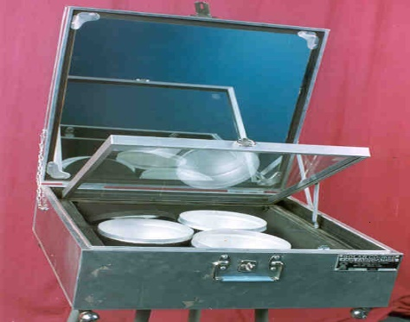**Solar cookers:** Solar cookers make use of solar heat by reflecting the solar radiations using a mirror directly on to a glass sheet which covers the black insulated box within which the raw food is kept. A new design of solar cookers is now available which involves a spherical reflector (concave or parabolic reflectors). Instead of plane mirror that has more heating effect and hence greater efficiency. The food cooked in solar cooker is more nutritious due to slow heating. However, it has the limitations that it cannot be used at night or on cloudy days.

**Figure: Domestic Solar Cooker**

* 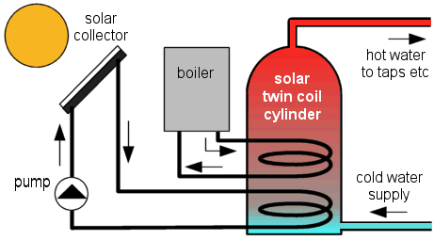**Solar water heaters:** It consists of an insulated box painted from inside and having a glass lid to receive and store solar heat. Inside the box it has black painted cooper coil through which cold water is made to flow in, which gets heated and flows out into the storage tank. The hot water from the storage tank fitted on roof tap is then supplied through pipe into building like hotels and hospitals.

**Figure: Solar Water Heater**

* + **Solar cells:** They are also known as photovoltaic cells or PV cells. Solar cells are made of thin wafers of semiconductor materials like silicon and gallium. When solar radiations fall on them, a potential difference is produced which causes flow of electrons and produce electricity. Silicon can be obtained from silica or sand, which is
  + 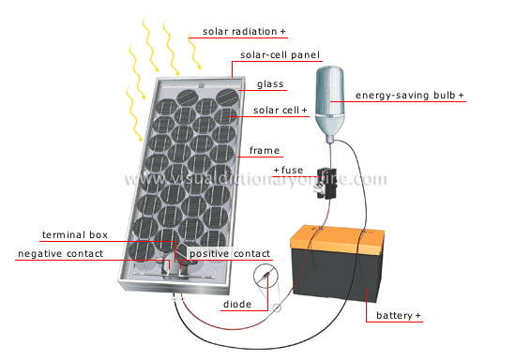

**Figure: Diagram showing solar cell system**

abundantly available and inexpensive. By using gallium arsenide, cadmium sulphide or boron, efficiency of the PV cells can be improved. A group of solar cells jointed together in a definite pattern from a solar panel which can harness a large amount of solar energy and can produce electricity enough to run street-light, irrigation water pump. Solar cells are widely used in calculators, electronic watches, street lighting, traffic signals, water pumps, etc. They are also used in artificial satellite for electricity generation.

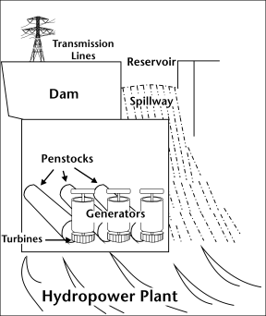

* **Hydro power (Hydro-electric Energy):** Hydropower energyis **renewable source** of energy. The water flowing in a river is collected by making big dams on the water bodies. The water is allowed to fall from a height. The blades of the turbine located at the bottom of the dam move with the fast moving water which in turn rotates the generator and produces electricity.

**Figure: Hydropower plant**

**Advantages**

* It is a clean source of energy.
* Hydropower plants do not pollute the environment.
* Hydel projects, not only provide cheap generation of electricity, but are renewable in nature.

**Environmental problems of large hydropower plant**

* Generally, the hydropower plants are established in hilly areas, causing heavy deforestation
* Destruction of forest wealth due to submergence
* Loss of wild life due to destruction of their habitats
* Increase the incidence of water related diseases
  + 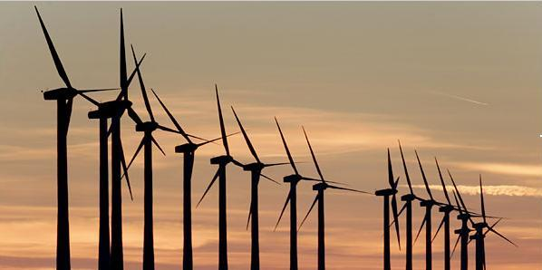**Wind Energy:** Wind energy is one of the most potential source of alternate energy, which is influenced by geographical factors. Wind energy is harnessed by using wind mills. Wind mill is driven by the energy of wind. Making use of this energy, the blade of the wind mill keep on rotating due to force of striking wind. Once the mill is turning due to force of wind, it can derive even a generator to get electricity. It is a non-polluting and sustainable source of energy but it is variable, irregular, unsteady and intermittent.

**Figure: Wind Mills**

* + **Geothermal Energy:** Geo-thermal energy is renewable **heat energy** from the underneath of the earth. The word geothermal comes from the Greek words geo and theme which means earth and heat respectively. Thus, *“The energy harnessed from the rocks present inside the earth is called geothermal energy.”* High temperature, high pressure steam fields below the earth’s surface in many places. This heat comes from the fission of radioactive material like thorium, uranium and potassium, naturally present in the rocks. There are some places in the world which have the temperature near the surface sufficiently high to produce steam which is then used to derive turbines and generate electricity in the usual manner. Geothermal energy has a very high efficiency and low initial cost but it is a highly local resource. In some places, steam or hot water comes out of the ground naturally through cracks in the form of natural geysers as in Manikaran, Haryana, Kullu and Sohana. In USA and New Zealand, there are several geothermal plants working successfully.

**Advantages**

* It does not produce any pollution, and does not contribute to the greenhouse effect.
* No fuel is needed.
* The power station does not cover much area, so there is not much impact on the environment.
* Once a geothermal power station built, the energy is almost free.

**Disadvantages**

* Lack of places where geothermal power stations can be built up.
* Type of rock above is also important; it must be of a type that can drill easily.
* Hazardous gases and minerals may come up from underground, and can be difficult to safely dispose off.
  + **Ocean and Tidal Energy:** The vast potential of energy of the seas and oceans which cover about three fourth of our planet, can make a significant contribution to meet the energy needs. Oceans contains energy in the form of temperature gradients, waves and tides and ocean current, which can be used to generate electivity in an environment friendly manner. Technologies to harness tidal power, wave power and ocean thermal energy is being developed, to make it commercially viable. Twice each day on every coastline in the world, bodies of water are pulled onto and off of the shore as a result of gravitational forces extended by the moon and sun. Only on ocean coast is this change large enough to notice, however, to take advantage as energy source.

The potential of tidal power as an energy source is clearly seen. Pieces of wood are carried onto beach and then off again every time the tide comes in or goes out. In theory, the energy that moves this wood cold also pushes against a turbine blade and turns a generator. In fact, the number of places on the earth where tides are strong enough to spin a turbine is relatively small.

**Advantages**

* Once a power plant built, the energy is almost free.
* No fuel is needed.
* Produces no greenhouse gases and other wastes.
* Produces electricity reliable.

**Disadvantages**

* The cost of building tidal power plants is significantly high.
* The alteration of tidal currents affects the habitat of the seabirds and the fish.
* Tidal energy is only available in a small number of regions.
  + **Biomass and Bio-energy**

Biomass is a renewable source of energy which may be defined as *“the waste material of living beings and the dead parts of the living being, i.e., plants, trees and animals.”* It includes cattle dung, wood, sewage, agricultural wastes or crop residues such as bagasse and rice husk. Biomass also includes biodegradable organic wastes from industries like sugar mills, breweries etc.

Biomass fuel is burned to release energy. It may be of three types:

**i. Solid biomass fuel:**  It includes wood, charcoal, animal dung and peat.

**ii. Liquid biomass fuel:** Biomass can be converted to liquid fuels, especially methanol and ethanol, which can be used in internal combustion engines of automobiles.

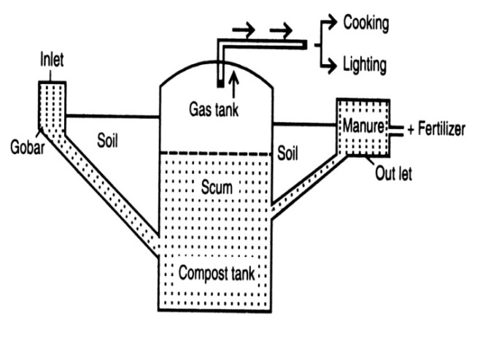**iii. Gas biomass fuel:** Biomass, particularly animal waste, can also be converted into biogas in biogas digesters, by using the process of anaerobic microbial decomposition. Biogas is a clean anaerobic fuel whose combustion process produces fewer pollutants than other combustible energy sources.

**Biogas:**

Biogas is a mixture of gases having methane as a main component. When organic matter undergoes anaerobic decomposition (≡ microbiological decomposition in absence of free oxygen) methane, ammonia, hydrogen and carbon dioxide are released. This mixture of gases is called biogas in which methane is a combustible gas.

**Composition-** CH4 – 55-60%, H2 ­– 7.4%, CO2 – 25-30%, N2 – 2.6%, H2S – Traces.

**Advantages-**

1. Ecofriendly – does not produce smoke
2. Cheaper fuel
3. No storage problem – directly used from bio gas plant through pipes
4. Spend slurry can be used as natural manure (fertilizer)

**Limitations-**

1. Gober gas should be used within 10 meters, (ii) It needs large area, (iii) Bad smell from its plant

**Application-**

1. Used as a domestic fuel in many villages, (ii) Used for lightning and power purposes

* **Nuclear Energy**

Nuclear energy is a sustainable source of energy. Nuclear energy, also called as **atomic energy**, was first discovered by French scientist **Henri Becquerel** in 1896. Nuclear energy is released from the nucleus of an atom. Nuclear energy is used as a power source. Nuclear energy is known for its high destructive power as evidenced from the nuclear weapons. The nuclear energy can also be harnessed for providing commercial energy.

**Production**

Nuclear energy is produced naturally and in man-made operations under human control.

1. **Naturally:** Some nuclear energy is produced naturally. For example, the Sun and other stars make heat and light by nuclear reactions.
2. **Man-Made:** Nuclear energy can be man-made too. Machines called **nuclear reactors**, parts of **nuclear power plants**, provide electricity for many cities. Man-made nuclear reactions also occur in the explosion of [**atomic and hydrogen bombs**](http://library.thinkquest.org/3471/abomb.html)**.**

Nuclear energy is produced in two different ways, in one; large nuclei are split to release energy. In the other method, small nuclei are combined to release energy.

* **Nuclear fission:** It is a nuclear change in which nucleus of certain isotopes with large mass number are split into two lighter nuclei on the bombardment by neutrons and a large amount of energy is released through a chain reaction.

92U235 + 0n1 36Kr92 + 36Ba141 + 3 0n1 + Energy

Nuclear reactors make use of nuclear chain reaction. In order to control the rate of fission, only 1 neutron released is allowed to strike for splitting another nucleus. Uranium235 nuclei are most commonly used in nuclear reactors.

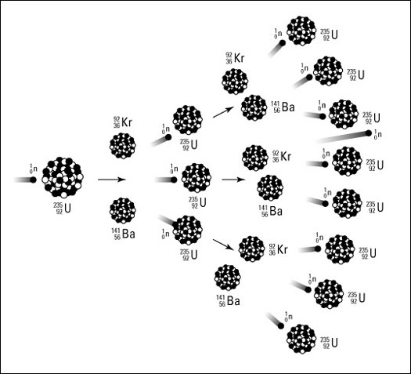

**Figure 5.11: Nuclear Fission – a chain reaction initiated by neutron**

* **Nuclear fusion:** In this process two isotopes of a light element are forced together at extremely high temperature (1 billion°C) until they fuse to form a heavier nucleus releasing enormous energy in the process. It is difficult to initiate the process but it reaches more energy than nuclear fission.

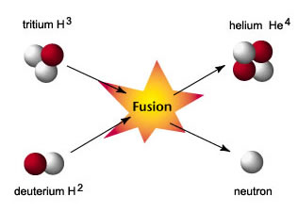

**Figure 5.12: Nuclear Fission reaction between hydrogen nuclei**

Nuclear fission reaction between two hydrogen-2 nuclei, which takes place at a very high temperature of 1 billion°C, one neutron and one fusion nucleus of helium-3 is formed along with a huge amount of energy.

1H2 + 1H2 3He2 + 0n1 + Energy

Nuclear energy has tremendous potential but any leakage from the reactor may cause devastating nuclear pollution. Disposal of the nuclear waste is also a big problem.

Nuclear power in India is still not well developed. There are four nuclear power stations with an installed capacity of 2005 MW. These are located at Tarapur (Maharastra), Rana Pratap Sagar near Kota (Rajasthan), Kalpakkam (Tamil-Nadu) and Narora (U.P.)

**Advantages of Nuclear Energy**

* Nuclear power plants need less fuel than ones which burn fossil fuels.
* Coal and oil burning plants pollute the air. Well-operated nuclear power plants do not release contaminants into the environment.

**Disadvantages of Nuclear Energy**

* One of the main disadvantages of nuclear energy is that nuclear explosions produce radiation, this radiation harms the cells of the body which can make humans sick or even cause them death.
* More expensive to build the plant for production of energy.
* Waste products dangerous and need to be carefully stored for long time.
* **Hydrogen as an alternative future resource of energy**

Increased energy use is the universal driver for raising the quality of life in all societies, from developing to developed countries. However, the present reliance on energy from fossil fuels produces unwanted side effects: environmental pollution that threatens human health, carbon dioxide emissions that accelerate global warming. The challenge is to find highly efficient ways to produce, deliver, and use energy that enhance quality of life but do not threaten the environment and climate or strain geopolitical relations.

Hydrogen is the simplest element known to man. Hydrogen is abundant in chemical compounds such as water and the organic compounds of biomass. As hydrogen burns in air, it combines with oxygen to form water and a large amount of energy (150 KJ/gm) is released. Due to its high calorific value, hydrogen can be serve as an excellent fuel. Production of hydrogen is possible by thermal dissociation, photolysis or electrolysis of water.

**Merits of hydrogen as an energy source**

* It is pollution free, the combustion of hydrogen generation only steam and liquid waters, hence it is completely safe from the environmental view point.
* As it is carbon free, there is no production of greenhouse gases, which cause global warming

**Demerits of hydrogen**

* Hydrogen is difficult to handle, store and transport.
* Hydrogen is highly inflammable and explosive in nature. Hence safe handling is required for using hydrogen as fuel.
* Currently more expensive than other energy sources.